Consecutive Issues Project & Teaching Guide
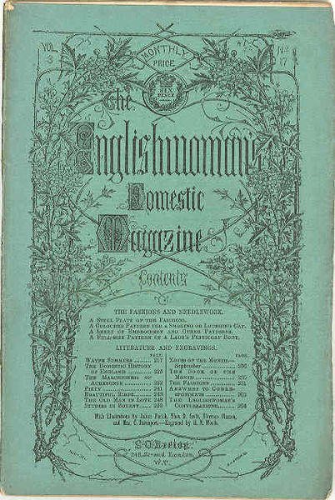
Teaching Guide

Assignment details:
This assignment is aimed at a university student audience but assumes no familiarity with historical or literary content outside of the assignment. As such it can be adapted to fit courses on literature, history, media studies, gender studies, marketing, advertising, or design.

Summary of assignment:
Students will examine consecutive numbers of a 19th century women’s magazine to practice historical inquiry, textual analysis, and media literacy skills, developing a group presentation to demonstrate their findings.

Learning objectives, skills, and goals involved:
- Analysis of primary sources for increased historical understanding
- Digital archival research skills
- Critical inquiry skills
- Critical reading skills
- Document skills (PDF selection, editing, and annotation)
- Analysis of print versus digitized primary sources
- Group work skills
- Presentation skills
- Contribution to collaborative knowledge-building

Suggested options for adaptation:

- The analysis questions furnished in this assignment can underpin an individual project rather than a group one.
- Students’ work on this inquiry can be assessed as a written analysis rather than a presentation. Other options would include a video presentation or a social media style video (e.g. 2023 examples would include a format like an Instagram reel or TikTok)
- Students can be provided a specific PDF number or issue rather than selecting their own. This can cut down on students’ initial sense of overwhelm, especially in a class of non-majors.
- The data collected in students’ tables can be collaboratively fit together to form detailed indexes of previously unindexed source material, and this can be part of a learning objective about collaborative knowledge production, digital projects, and/or distant reading. This collaboration can be a part of the assignment or a separate piece of work completed by the instructor or a particular student team.
- Students could transcribe content they find particularly interesting or surprising.
- Comparison of OCR vs. human transcription.
- Students could research more about a particular debate, writer, or theme they noticed.

Notes to adapt for your own class are in italics in the student-facing material below.

[This assignment was inspired by the pedagogical materials at the Media History Digital Library, especially the assignment titled “Excavating Historical Debates using Primary Sources” shared for reuse in the MHDL by Jocelyn Szczepaniak-Gillece, University of Wisconsin-Milwaukee.]

Student Facing Material begins on the following page. (This is the assignment sheet to distribute for students – feel free to adapt to your class and needs as desired.)

Assignment Description: Consecutive Issues Project

For this project, you and your group will analyze a range of a historic magazine to notice its cultural content. You will read carefully for clues, annotate and organize your information, and make inferences from your analysis, and present your findings.

Assessment Criteria: (adapt to class needs as a rubric or grading guide)
- Completion of analytical log
- Quality of annotation
- Response to analytical questions
- Detail of analysis
- Presentation length and expertise
- Presentation content & detail
- Presentation creativity / quality
- Quality of group workshare

Browse the Englishwoman’s Domestic Magazine and select three consecutive monthly issues (At the time, these were called “numbers”.) You may select any year between 1852 and 1867. Note that each number/issue has between 32-48 pages and may or may not include a cover and advertising depending on the file you select.

Link to the magazine: https://jmsw.github.io/edm-index/

With your group, create a PDF containing only the page range of each number. Many of the links go to very long documents consisting of a year or more of the magazine. Download the larger PDF and create a smaller one with only the page range you will analyze.
Share these PDFs with your group.
Annotate this PDF either individually or as a group, using the highlighting and annotation tool (specify a tool that your class has use of and access to).

Read this magazine. Highlight, annotate, and keep track of what stands out to you as readers.

Log the magazine’s component parts on a table like the following: (Cut and paste or use a separate document or spreadsheet.) Use the “tab” key in final slot to create additional rows as needed).

PDF page numbers | Original page numbers (if applicable) | Content Item – Title, creator if supplied  If it is partial (for example, a serial section of a longer series or work), be sure to note what is included in this part | Content Genre/Type  Fiction, poetry, nonfiction informational article, advice column, advertising

When you have completed indexing the content of your magazine issues with your group, answer the following questions. Whenever possible, give examples and short quotations from your magazines, to illustrate your points.

Questions to consider as you shape your analysis:

- What patterns do you notice in the content of these issues? What ideas or concepts seem to come up a lot? Look for repetition.
- Who is creating this content? What parts of the magazine seem to be the magazine itself (its editors) speaking, vs. the voice of contributors? Are the contributors named or unnamed? Be sure to note this under “Content Item” above whenever possible.
- How much of the magazine’s allotted page space is given to different content? Can you infer anything about the magazine or its readers from the ratio of what is emphasized?
- What parts of the magazine are in response to other parts? What stands alone?
- Does the copy you are looking at include a cover, advertising pages, and/or a supplement (something extra like an illustrated fashion plate or a pattern to make something?) If so, be clear about that in your table above.
- What can you infer about this magazine’s concept of its readers?
- Do you notice any issues or debates in the content? Are there any controversial issues? If so, describe them. Does the magazine ever take a side? Use quotations to show where you see this.
- What do you notice here that is surprising to you? Give at least one example of something that changed your perception of this moment or defied your expectations.
- What is it like reading these magazines in digital form (as PDFs)? Can you think of ways that reading like this is a different experience from reading them in their original form?

Use your responses to these questions to create a 10-12 minute presentation with a historical argument, which includes examples to help support your point. In shaping a historical argument, strive for a debatable claim. If you have trouble generating one, sometimes a basic formula like this can help jumpstart your thinking: “While stereotypes indicate __[not your argument, something obvious, basic, or too much like a summary]__ , our group’s close reading of this magazine shows that actually __[a theme in your interesting findings]__”

You do not need to include the answers to all questions in your presentation, but you will turn in a presentation documentation that includes both your answers to the piece and the data from your table.

Once finalized, one group member should also enter the data from your table in our collaborative class index, located here.

